**Odometry of a Differential Drive Robot**

Using the python programming language, a program to calculate the odometry data of differential drive robot was created. The program calculates the left and right wheel speeds based on encoder outputs at 2Hz. Every 0.5 seconds (Δ𝑡) the encoders output the angular velocities, 𝜔 (rad/s), of the wheels. This data is used to calculate the speeds of the left and right wheels, 𝜗; given the formula 𝜗=𝜔∙𝑟, where 𝑟 is the radius of the wheels. Once the speeds of left and right wheels then the displacement (Δ𝑠) of each wheel can be determined from the formular; Δ𝑠 = 𝜗 Δ𝑡. The position of the robot can be determined from change in orientation and displacement of the entire robot. To determine the orientation (Δθ); the following formula can be used: Δθ= Δ𝑠r-Δ𝑠l/2L. Where 2L is the width of the robot. The change in x (Δx) and y (Δy) position can be determined using the following formulas: Δx = Δs(θ+Δθ/2), Δy = Δs(θ+Δθ/2).

The program outputs these values as seen in the Table 1.0 below.



Table 1.0 - Differential Drive Robot Odometry Data

The program also outputs visualizations of the data in Table 1.0. See figure 1.0 below:

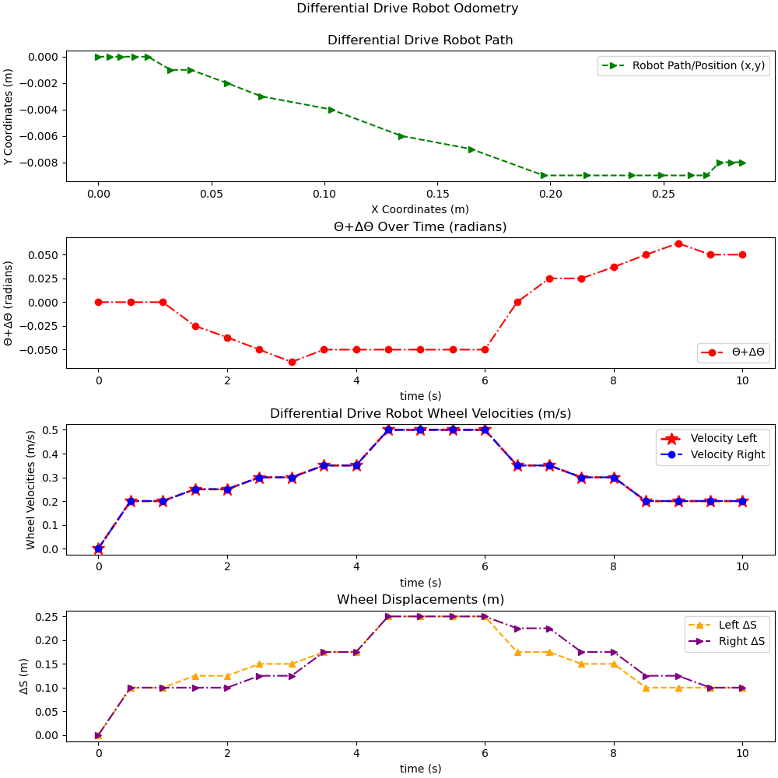

Figure 1.0 – Visualizations of Differential Drive Robot Odometry

The first plot in Figure 1.0, Differential Drive Robot Path, shows the position of the robot over time. The second plot (Δθ Over Time (radians)) shows the change in the robot’s orientation (θ) over time. The third (Differential Drive Robot Wheel Velocities (m/s)) and fourth (Wheel Displacements (m)) plots show the left and right wheel velocities and displacements of robot, respectively. We can see from the Differential Drive Robot Wheel Velocities (m/s) plot that the right and left wheel speeds are differentiate so little that it’s difficult to distinguish them apart. However, we can see that these small differences in wheels speeds have a larger impact on the wheel displacement (Wheel Displacements (m) plot) and overall path (Differential Drive Robot Path plot) the robot takes.